Instructor Documentation for Sona System Software for the REP Program

Introduction and Getting Started
The Experiment Management System is used for the scheduling and management of a research participant pool. As an instructor, your interaction with the system will be minimal, and hopefully painless. Your primary use of the system will be to check on the credit status of students (participants) in your courses. In some cases you may also have the ability to grant credits to your students, as well as view which studies are available to students.
The system works best if you use a web browser that is less than 2 years old. It works well with all current versions of Firefox, Chrome, and Safari. It will work with other web browsers, and with older versions of the browsers noted above, however the layout may not be as clean. Using an older web browser will lose no functionality. Ask your IT department if you need help with installing or using a web browser. This documentation presumes you have a basic knowledge of how to use the web. On this system, it is not necessary to use the Back button. You can always use the toolbar on the top to navigate anywhere on the site.

Changing Your Password
To change your password or other information, choose the My Profile choice from the top toolbar.
If you change your password, please be sure to select a password you do not use on any other systems or websites, which is a good computing practice.
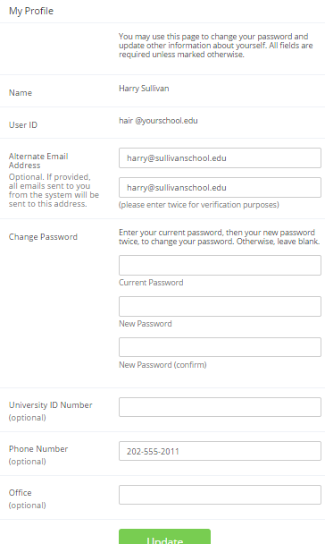
\Depending on how your system is configured, you may enter an email address on this page. You will be asked to enter it twice when changing the address, to ensure it is typed correctly.

Logging In
Your administrator will provide you with a username and password to log in to the site (if SSO is not enabled), as well as the URL (web address). When you go to the front page of the site (the login page), you may see a link to request an account. This form is only for participants. Do not use this form to request an account, as participant accounts have an entirely different set of privileges, which are not appropriate for a researcher.
If you have forgotten your password and the system is configured to allow password retrieval, you will see a link where you may choose to have your password reset and a new password emailed to you. Once you log in, you will be presented with a Main Menu with a few options.
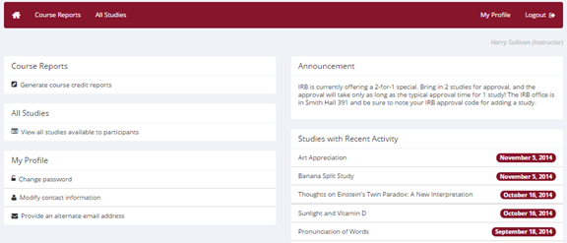

Generating and Viewing Course Reports
On the Main Menu that you see after logging in, you will see an option to generate course reports. Once you click on that, you will see a list of all the courses that you are listed as an instructor for. You have the option to generate reports for each of those courses.
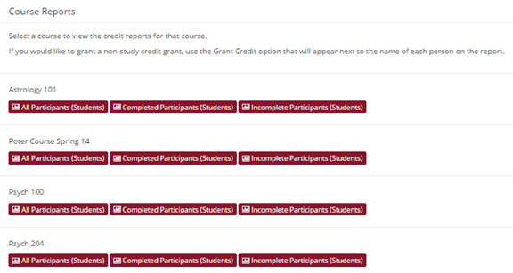
You have three choices for the type of report you would like to generate. All Participants will list all the participants that are in the course. Completed Participants will list only the participants who have met or exceeded their credit requirements. Incomplete Participants will list only the participants who have not met their credit requirements. Click the link for the desired report.
The report will be listed in alphabetical order by participants’ last name. Participants that have not completed their requirements will be highlighted in bold. For privacy and ethics reasons, you will never see exactly which studies the students participated in. You will only see a summary of their credit earnings. If for some reason this information is needed, the administrator can produce such a report for you using the Course Credit History report available to them.
If your system is configured as such, you will see a credit status for the participant overall, as well as for the listed course. If this is the case, you should look at a participant’s credit for the course to determine if they have completed their requirements. If you do not see such a column (“Credits Earned for Course”), then you only need to be concerned with the overall credit completion status for the participant. If the report is too wide to be printed easily, you can use the Printer-Friendly format. A link to that will appear at the bottom of the report.
The report also includes a column indicating the Overall Unexcused No-Shows a participant has accrued. If you have a policy whereby you give some type of bonus for participants who do not accrue any unexcused no-shows, then use this column to determine which participants fit into that category (look for values of 0).
If you would prefer to deal with the information in CSV (comma-separated) format, for easy import into a spreadsheet program like Excel, use the CSV link at the bottom of the report to generate such a data file. If you have a problem working with the CSV format file, please contact your IT department for assistance. CSV is a standard data format and they are quite familiar with it.
To generate a new report, choose the Main Menu link from the left toolbar and proceed from there.

Viewing Your Students’ Available Studies
In some cases, you may have the ability to view what studies are available in the system to participants. This is useful if you want to discuss information or concepts from those studies in class, as a part of the educational experience. If such an option is available, you will see an All Studies link after you login. If you click this, you will see a list of studies, along with an option to filter to only studies that have available timeslots. You may then click on any study to view more about it. For privacy reasons, you may not see who has signed up for any of the studies.
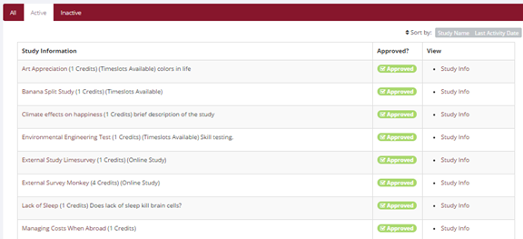

Logging Out
When you are done using the system, choose Logout from the top toolbar to log out. You are now logged out. It is always a good security measure to close all your browser windows as well, especially if you are using a computer that is shared by others.

